Technical Design Document for - Feedback - 4536

Date: 10-March-2023

Table of Contents

Problem Statement: 3

Solution Details 3

Steps to perform: 4

Technical Details:……………………………………………………………………………………………………………………………….6

# Problem Statement:

* The current process of changing record owners on multiple objects is time-consuming and impacts productivity, which affects our ability to meet commercial demands. The process involves creating files, submitting them, and performing data integrity checks, which takes 5-10 hours and can vary greatly depending on the volume or errors in the load.
* Users require an efficient and streamlined way to transfer ownership of multiple records across various objects, including accounts, contacts, leads, opportunities, and account or opportunity team members. This functionality will enable users to perform these actions independently without requiring Nagarro intervention, freeing up valuable time and resources for other critical tasks.
* In addition to transferring ownership, users should also be able to approve or reject multiple account owner change approval requests directly from the same interface. This will further improve efficiency and reduce the time required for this process.

# Solution Details:

To address the challenges of the current process of changing record owners on multiple objects, we propose the development of a custom component that will allow users on the marketing team to perform mass transfers of records across various objects without requiring Nagarro intervention. The custom component will be designed as a Salesforce Lightning Web Component, utilizing the Salesforce Lightning Design System (SLDS) for a consistent and modern user interface.

The custom component will have the following features:

• User Interface: The custom component will have a user-friendly interface that allows users to select multiple records from different objects, including accounts, contacts, leads, opportunities, and account or opportunity team members.

• Mass Transfer Functionality: The custom component will allow users to perform mass transfers of records to new owners. Users can transfer ownership of multiple records at once by selecting them in the interface and specifying the new owner.

• Approval or Rejection of Account Owner Change Requests: The custom component will enable users to approve or reject multiple account owner change requests directly from the same interface, streamlining the approval process and reducing the time required for this process.

Overall, the proposed custom component will provide an efficient and streamlined way for users to transfer ownership of multiple records, reducing the time and effort required and improving productivity.

# Steps to perform:

1. From the Crowley Sales App, navigate to the Account Tab.
2. Look for the Quick Action labelled **'Mass Transfer'** on the Account Tab and click on it
3. This will open a pop-up modal that looks like the following:

1. To select the user from which you want to transfer records, use the **'Transfer From'** lookup box. You can select from both active and inactive users, providing flexibility in selecting the source.
2. To select the user to which you want to transfer records, use the **'Transfer To'** lookup box. You can only select from active users in this field.
3. Select the checkboxes for the objects that you want to transfer records for.
4. Click the **'Search'** button, and a list of records for selected objects will be displayed in different tabs as follows:

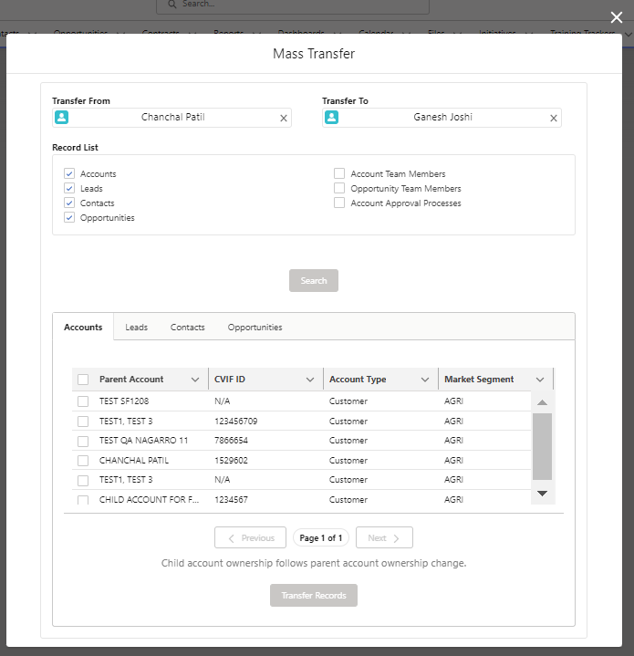

1. After selecting multiple records, click on the 'Transfer' button located below to initiate the transfer process.

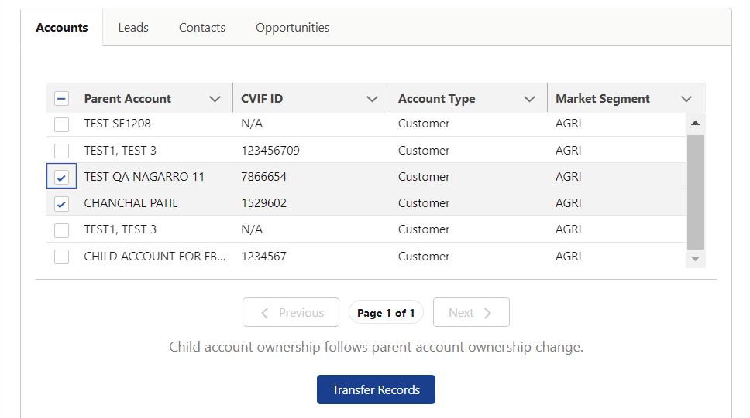

1. To approve or reject account owner change approval requests, select the 'Account Approval Processes' checkbox.
2. After selecting the 'Account Approval Processes' checkbox, a dropdown will appear with four search conditions to filter approval requests by, as follows:

1. Selecting an option will show records accordingly.
2. Then we can Approve or Reject selected record by clicking on buttons below:

# Technical Details:

Components Flow Diagram:

Here’s the technical description of all the components of this functionality:

**Custom Button:**

|  |  |
| --- | --- |
| Mass_Transfer | This custom button is located on the list view tab of the Account object. It invokes an Aura Component (sal_MassTransferRecordAura__c) via a URL call. |

**Aura Component Bundle:**

|  |  |
| --- | --- |
| sal_MassTransferRecordAura__c | This Aura component has parent LWC(sal_MassTransferRecord) embedded in it. |

**Lightning Web Components (LWCs):**

|  |  |
| --- | --- |
| sal_MassTransferRecord | This is the parent component of all other LWCs in the data model. It features a pop-up design with a SLDS style, containing two instances of sal_LookupPill for 'Transfer from' and 'Transfer To'. Additionally, it includes an SLDS grid with checkboxes for the record list and a search button to trigger child components (sal_GenericTableCmp and sal_AccApprovalTable) in tabset format. |
| sal_LookupPill | This component is a custom lookup that enables users to search for users based on a search term. It also filters the results based on a user selected in another instance. |
| sal_GenericTableCmp | This component is a generic component that displays a data table for multiple objects at different instances. It has the main feature of data model, i.e., transferring the ownership of object records. The component instances are displayed based on the checkboxes selected in the parent component. |
| sal_AccApprovalTable | This component is used specifically with the Account Approval Records Tab. It features a dropdown menu that allows users to select a filter condition to query the underlying data, and a data table that displays the filtered results. Additionally, it includes 'Approve/Reject' buttons that enable users to modify the status of the selected records in the data table. |

**Apex Class**:

|  |  |
| --- | --- |
| sal_tableController | It is controller class of all the LWCs. And It has AuraEnabled methods: getRecordList, searchLookupPill, updateSelectedRecords, updateTeamMemRecords, accountApprovalDataGet, approveOrRejectAccounts |
| Test_tableController | This is the test class for Apex controller class. Having test coverage of 80+. |

**Apex Controller Class Methods**:

|  |  |
| --- | --- |
| getRecordList | This method is called on Search button to get Record list data on LWC datatables as per ObjectName is passed |
| searchLookupPill | This method provides a search functionality for lookup boxes based on search term and is called on lookup boxes to search for users in "Transfer From" and "Transfer To" |
| updateSelectedRecords | This method is called on 'Transfer' button on LWC, to update the owner of selected records of a given object type(Other than AccTM/OppTM) with a provided user in 'Transfer To' box. |
| updateTeamMemRecords | This method is called on 'Transfer' button on LWC, to update the owner of selected records of a given object type(Only AccTM/OppTM) with a provided user in 'Transfer To' box. |
| accountApprovalDataGet | This method retrieves a list of accounts requiring approval based on a given dropdown label and 'Transfer To' User for Account Approval Requests DataTable, with the label determining the type of approval request. |
| approveOrRejectAccounts | This method is called on 'Approve/Reject' button on Account Approval Requests Tab DataTable. It will approve or reject selected list of account approval records. |

**Custom Permission:**

|  |  |
| --- | --- |
| sal_Mass_Transfer_Permission | This is a custom permission that grants access to the Mass Transfer functionality. |

**Permission Set:**

|  |  |
| --- | --- |
| Allow_Mass_Transfer | This is a Permission Set that provides access to the custom permission for the Mass Transfer functionality. |